**Gestionarea unui club sportiv**

Hurloi Selena-Andreea

Grupa 242

# 1. Prezentați pe scurt baza de date (utilitatea ei)

Scopul proiectului este de a tine evidenta informatiilor specifice unui club sportiv. Cluburile sportive se impart in mai multe departamente, iar in cadrul departamentelor se gasesc echipele. Aceste echipe pot beneficia de sponsori. Antrenorii lucreaza pentru cluburi, insa acestia se pot angaja la mai multe. Cluburile inchiriaza locatii pentru antrenamente unde sportivii isi desfasoara pregatirea. La competitii, echipele sunt insotite de antrenor, iar in cadrul acestora primesc punctaje. Pentru premiile obtinute in decursul carierei, sportivii sunt premiati cu titluri.

# 2. Diagrama Entitate-Relație(ERD)

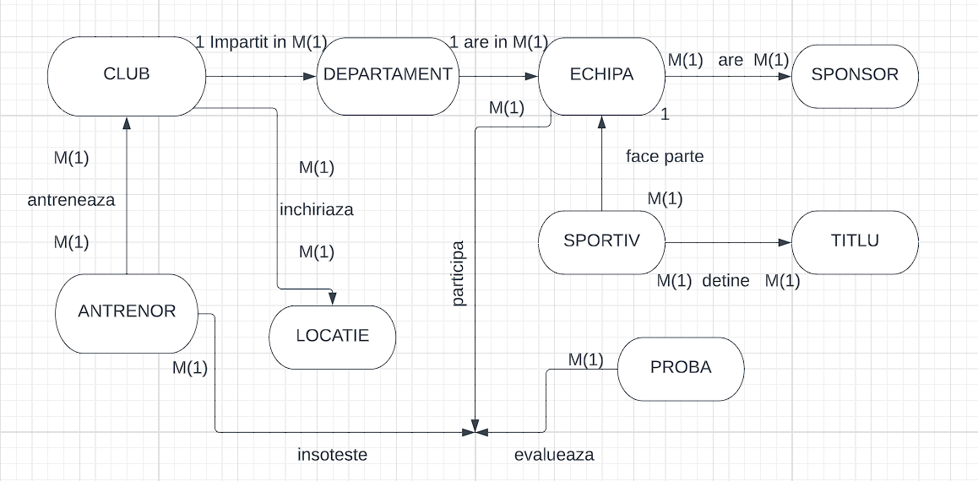

# 3. Diagrama Conceptuală

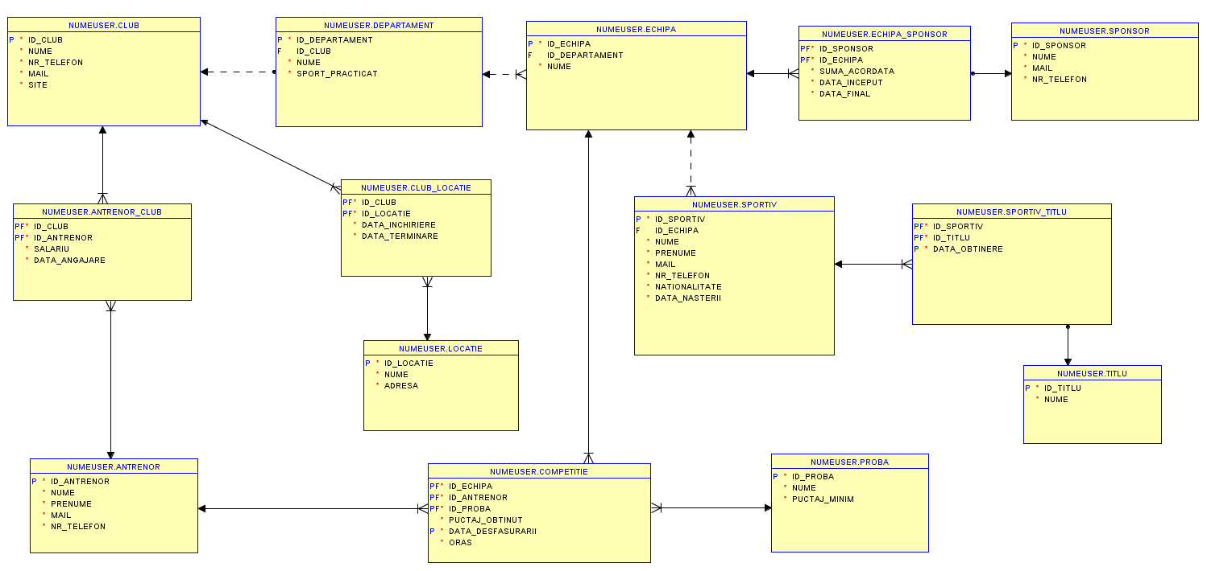

# 4. Implementare si inserare

Create table CLUB  
 (id_club int constraint id_club_pk PRIMARY KEY,  
 nume VARCHAR(20) CONSTRAINT name_club not null,  
 nr_telefon VARCHAR(20) CONSTRAINT nr_telefon_club not null,  
 mail VARCHAR(200) CONSTRAINT mail_club not null,  
 site VARCHAR (200) CONSTRAINT site_facultate not null  
 );

CREATE SEQUENCE ID  
INCREMENT by 1  
START WITH 100  
MAXVALUE 10000  
NOCYCLE;  
   
Insert into Club  
values (ID.nextval,'CS Gura Humorului','0745698654','cs.humorului@gmail.com','www.cs.gurahumorului.ro');  
Insert into Club  
values (ID.nextval,'CSM Targu Jiu','0745654365','targujiu.csm@gmail.com','www.csm.targu_jiu.ro');  
Insert into Club  
values (ID.nextval,'Alpin Sport','0712567342','alpin.sport@gmail.com','www.alpin_sport.ro');  
Insert into Club  
values (ID.nextval,'Muschetarii','0786543213','muschetarii@gmail.com','www.muschetarii.ro');  
Insert into Club  
values (ID.nextval,'CSM Atetism Sinaia','0786432113','atetism_sinaia@gmail.com','www.Atetism_sinaia.ro');  
   
select * from club

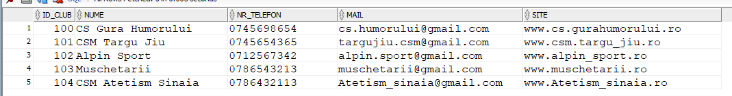

create table DEPARTAMENT  
 (id_departament int constraint id_departament_pk PRIMARY KEY,  
 id_club int, constraint id_club_fk FOREIGN KEY (id_club) references CLUB(id_club),  
 nume varchar (20) not null,  
 sport_practicat varchar (20) not null  
 );

CREATE SEQUENCE ID_DEP  
INCREMENT BY 1  
START WITH 100  
MAXVALUE 100000  
NOCYCLE;   
   
INSERT INTO Departament  
VALUES (ID_DEP.NEXTVAL,100,'Health_Wellness','pilates');  
INSERT INTO Departament  
VALUES (ID_DEP.NEXTVAL,103,'Sharp Focus Sports','rugby');  
INSERT INTO Departament  
VALUES (ID_DEP.NEXTVAL,104,'Active Plus','culturism');  
INSERT INTO Departament  
VALUES (ID_DEP.NEXTVAL,102,'Sport Motiva','karate');  
INSERT INTO Departament  
VALUES (ID_DEP.NEXTVAL,101,'Majestic','balet');  
   
 SELECT * FROM departament

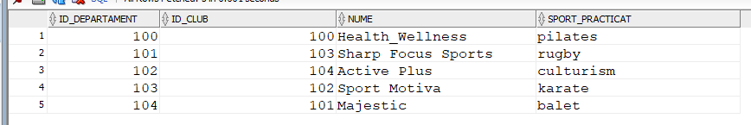

CREATE TABLE ECHIPA (id_echipa int constraint id_echila_pk PRIMARY KEY,  
 id_departament int, constraint id_departament_fk FOREIGN KEY (id_departament) references DEPARTAMENT(id_departament),  
 nume VARCHAR(20) NOT NULL  
 );   
CREATE SEQUENCE ID_ECH  
INCREMENT BY 1  
START WITH 100  
MAXVALUE 100000  
NOCYCLE;   
   
INSERT INTO Echipa  
VALUES (ID_ECH.NEXTVAL,100,'Iconic');  
INSERT INTO Echipa  
VALUES (ID_ECH.NEXTVAL,103,'Lightning Legends');  
INSERT INTO Echipa  
VALUES (ID_ECH.NEXTVAL,104,'The Elite Team');  
INSERT INTO Echipa  
VALUES (ID_ECH.NEXTVAL,102,'Crew X');  
INSERT INTO Echipa  
VALUES (ID_ECH.NEXTVAL,101,'Ballerina Bellas');  
INSERT INTO Echipa  
VALUES (105,100,'Bears');  
INSERT INTO Echipa  
VALUES (106,100,'We Are The Champions');  
   
SELECT * FROM echipa

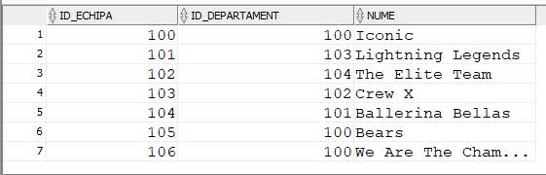

CREATE TABLE SPORTIV ( id_sportiv int constraint id_sportiv_pk PRIMARY KEY,  
 id_echipa int, constraint id_echipa_fk FOREIGN KEY (id_echipa) references ECHIPA(id_echipa),  
 nume VARCHAR(20) CONSTRAINT name_sportiv NOT NULL,  
 prenume VARCHAR(20) CONSTRAINT prenume_sportiv NOT NULL,  
 mail VARCHAR(20) CONSTRAINT mail_sportiv NOT NULL,  
 nr_telefon VARCHAR(20) NOT NULL,  
 nationalitate VARCHAR(20) NOT NULL,  
 data_nasterii DATE NOT NULL  
 );  
CREATE SEQUENCE ID_sportiv2  
INCREMENT BY 1  
START WITH 100  
MAXVALUE 100000  
NOCYCLE;   
   
INSERT INTO Sportiv  
VALUES(ID_sportiv2.NEXTVAL, 100, 'Ioan', 'Maria', 'ioan.maria@gmail.com','0765432189','romana',  
TO_DATE('27-01-2002','dd-mm-yyyy'));  
INSERT INTO SPORTIV  
VALUES(ID_sportiv2.NEXTVAL, 103, 'Mihailescu', 'Valeriu', 'vale.miha@gmail.com','0765232187','romana',  
TO_DATE('23-09-1999','dd-mm-yyyy'));  
INSERT INTO SPORTIV  
VALUES(ID_SPORTIV2.NEXTVAL, 104, 'Ion', 'Bogdan', 'ion.bogdan@gmail.com','0765232187','romana',  
TO_DATE('25-10-2000','dd-mm-yyyy'));  
INSERT INTO SPORTIV  
VALUES(ID_SPORTIV2.NEXTVAL, 102, 'Mira', 'Kiko', 'mira.kiko@gmail.com','0764634261','bulgara',  
TO_DATE('23-11-1998','dd-mm-yyyy'));  
INSERT INTO SPORTIV  
VALUES(ID_SPORTIV2.NEXTVAL, 101, 'Gherghe', 'Lara', 'lara.star@gmail.com','0764634261','romana',  
TO_DATE('22-04-1998','dd-mm-yyyy'));  
INSERT INTO Sportiv  
VALUES(105, 102, 'Coman', 'Laurentiu', 'laur.coman@gmail.com','0765433265','romana',  
TO_DATE('24-03-2003','dd-mm-yyyy'));  
INSERT INTO Sportiv  
VALUES(106, 108, 'Nitu', 'Victor', 'vic.nitu@gmail.com','0723433269','romana',  
TO_DATE('25-04-2001','dd-mm-yyyy'));   
INSERT INTO Sportiv  
VALUES(107, 108, 'Ioan', 'Alex', 'alex.ioan@gmail.com','0723435276','romana',  
TO_DATE('25-04-2001','dd-mm-yyyy'));  
INSERT INTO Sportiv  
VALUES(108, 107, 'Chirita', 'Ruxandra', 'ruxy23@gmail.com','0723432765','romana',  
TO_DATE('13-06-1999','dd-mm-yyyy'));  
INSERT INTO Sportiv  
VALUES(109, 107, 'Luita', 'Gino', 'gino35@gmail.com','0723432381','romana',  
TO_DATE('12-07-1999','dd-mm-yyyy'));  
   
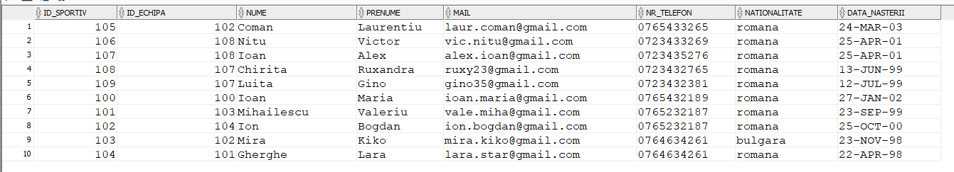SELECT * FROM sportiv

CREATE TABLE ANTRENOR (id_antrenor int constraint id_antrenor_pk PRIMARY KEY,  
 nume VARCHAR(20) CONSTRAINT name_antrenor NOT NULL,  
 prenume VARCHAR(20) CONSTRAINT prenume_antrenor NOT NULL,  
 mail VARCHAR(20) CONSTRAINT mail_antrenor NOT NULL,  
 nr_telefon VARCHAR(20) NOT NULL);  
CREATE SEQUENCE ID_antrenor  
INCREMENT BY 1  
START WITH 100  
MAXVALUE 100000  
NOCYCLE;   
   
INSERT INTO ANTRENOR  
VALUES (ID_antrenor.NEXTVAL,'Gigi','Vasile','gigi.vasi@gmail.com','0756432176');  
INSERT INTO ANTRENOR  
VALUES (ID_antrenor.NEXTVAL,'Bicu','Maria','maria.bicu@gmail.com','0753421176');  
INSERT INTO ANTRENOR  
VALUES (ID_antrenor.NEXTVAL,'Luiza','Amalia','lulu.ama@gmail.com','0753421234');  
INSERT INTO ANTRENOR  
VALUES (102,'Aslan','Mihai','mihai45@gmail.com','0753421321');  
INSERT INTO ANTRENOR  
VALUES (ID_antrenor.NEXTVAL,'George','Miriam','miriam27@gmail.com','0753425376');  
   
SELECT * FROM antrenor

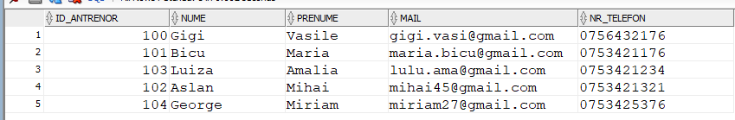

CREATE TABLE PROBA (id_proba int constraint id_proba_pk PRIMARY KEY,  
 nume VARCHAR(20) CONSTRAINT name_proba NOT NULL,  
 puctaj_minim NUMBER(7,2) NOT NULL);

CREATE SEQUENCE id_proba  
INCREMENT BY 1  
START WITH 100  
MAXVALUE 100000  
NOCYCLE;   
   
INSERT INTO proba  
VALUES(id_proba.NEXTVAL,'Drop Gol',7.5)  
INSERT INTO proba  
VALUES(id_proba.NEXTVAL,'Fit Challenge',8)  
INSERT INTO proba  
VALUES(id_proba.NEXTVAL,'makiwara',5.5)  
INSERT INTO proba  
VALUES(id_proba.NEXTVAL,'Balet Modobradi',9)  
INSERT INTO proba  
VALUES(id_proba.NEXTVAL,'Mobility',5.5)  
   
SELECT * FROM proba

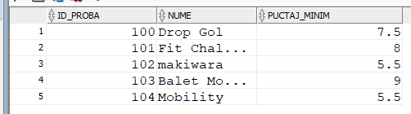

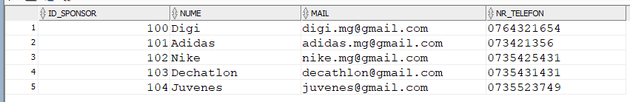CREATE TABLE SPONSOR (id_sponsor int constraint id_sponsor_pk PRIMARY KEY,  
 nume VARCHAR(20) CONSTRAINT name_sponsor NOT NULL,  
 mail VARCHAR(20) CONSTRAINT mail_sponsor NOT NULL,  
 nr_telefon VARCHAR(20) NOT NULL);  
CREATE SEQUENCE id_sponsor  
INCREMENT BY 1  
START WITH 100  
MAXVALUE 100000  
NOCYCLE;  
   
INSERT INTO sponsor  
VALUES(id_sponsor.NEXTVAL,'Digi','digi.mg@gmail.com','0764321654')  
INSERT INTO sponsor  
VALUES(id_sponsor.NEXTVAL,'Adidas','adidas.mg@gmail.com','073421356')  
INSERT INTO sponsor  
VALUES(id_sponsor.NEXTVAL,'Nike','nike.mg@gmail.com','0735425431')  
INSERT INTO sponsor  
VALUES(id_sponsor.NEXTVAL,'Dechatlon','decathlon@gmail.com','0735431431')  
INSERT INTO sponsor  
VALUES(id_sponsor.NEXTVAL,'Juvenes','juvenes@gmail.com','0735523749')  
   
SELECT * FROM sponsor

CREATE TABLE TITLU (id_titlu int constraint id_titlu_pk PRIMARY KEY,  
 nume VARCHAR(20) CONSTRAINT name_titlu NOT NULL);  
CREATE SEQUENCE id_titlu  
INCREMENT BY 1  
START WITH 100  
MAXVALUE 100000  
NOCYCLE;  
   
INSERT INTO titlu  
VALUES(id_titlu.NEXTVAL,'Festival Tineri Loc1')  
INSERT INTO titlu  
VALUES(id_titlu.NEXTVAL,'Primava 2022 Loc3')  
INSERT INTO titlu  
VALUES(id_titlu.NEXTVAL,'Jocurile Marii Loc2')  
INSERT INTO titlu  
VALUES(id_titlu.NEXTVAL,'Joc sportiv juniori')  
INSERT INTO titlu  
VALUES(id_titlu.NEXTVAL,'Jocurile Europei')  
   
SELECT * FROM titlu

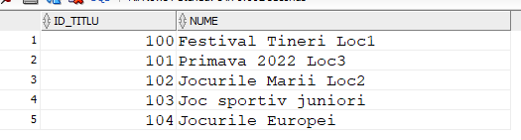

CREATE TABLE COMPETITIE (id_echipa int, constraint id_echipa_fk_comp FOREIGN KEY (id_echipa) references ECHIPA(id_echipa),  
 id_antrenor int, constraint id_antrenor_fk_comp FOREIGN KEY (id_antrenor) references ANTRENOR(id_antrenor),  
 id_proba int, constraint id_proba_fk_comp FOREIGN KEY (id_proba) references PROBA(id_proba),  
 puctaj_obtinut NUMBER(7,2) NOT NULL,  
 data_desfasurarii DATE NOT NULL,  
 oras VARCHAR(20) NOT NULL,  
 CONSTRAINT pk_competitie primary key(id_echipa,id_antrenor,id_proba)  
 );  
INSERT INTO competitie  
VALUES(103,101,102,5.2,TO_DATE('22-06-2015','dd-mm-yyyy'),'Bucuresti')  
INSERT INTO competitie  
VALUES(104,102,101,10,TO_DATE('21-06-2018','dd-mm-yyyy'),'Iasi')  
INSERT INTO competitie  
VALUES(102,104,100,4.6,TO_DATE('23-02-2011','dd-mm-yyyy'),'Barcelona')  
INSERT INTO competitie  
VALUES(102,103,104,10,TO_DATE('23-07-2018','dd-mm-yyyy'),'Suceava')  
INSERT INTO competitie  
VALUES(104,102,101,3.4,TO_DATE('21-06-2019','dd-mm-yyyy'),'Bucuresti')  
INSERT INTO competitie  
VALUES(102,104,103,5.2,TO_DATE('15-08-2022','dd-mm-yyyy'),'Buzau')  
INSERT INTO competitie  
VALUES(102,104,103,8.2,TO_DATE('22-06-2016','dd-mm-yyyy'),'Bucuresti')  
INSERT INTO competitie  
VALUES(102,103,104,6.9,TO_DATE('12-05-2018','dd-mm-yyyy'),'Campina')  
INSERT INTO competitie  
VALUES(104,103,102,7.9,TO_DATE('13-06-2021','dd-mm-yyyy'),'Slatina')  
INSERT INTO competitie  
VALUES(102,101,103,5.8,TO_DATE('26-08-2020','dd-mm-yyyy'),'Constanta')  
INSERT INTO competitie  
VALUES(108,101,102,10,TO_DATE('22-06-2015','dd-mm-yyyy'),'Bucuresti')  
INSERT INTO competitie  
VALUES(107,102,104,3,TO_DATE('22-06-2015','dd-mm-yyyy'),'Galati')

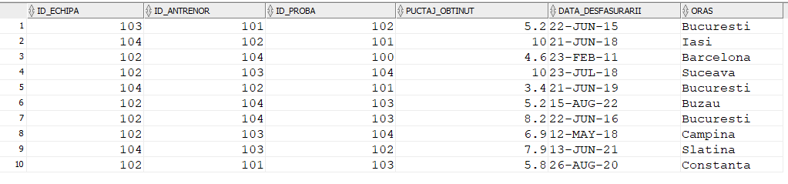

CREATE TABLE ANTRENOR_CLUB (id_club int, constraint id_club_fk_comp FOREIGN KEY (id_club) references CLUB(id_club),  
 id_antrenor int, constraint id_antrenor_fk_compus FOREIGN KEY (id_antrenor) references ANTRENOR(id_antrenor),  
 salariu int NOT NULL,  
 data_angajare DATE NOT NULL,  
 CONSTRAINT pk_antrenor_club primary key(id_club,id_antrenor)  
 );  
INSERT INTO Antrenor_Club  
VALUES(100,101,1772,TO_DATE('22-04-2012','dd-mm-yyyy'))  
INSERT INTO Antrenor_Club  
VALUES(102,100,1970,TO_DATE('21-06-2020','dd-mm-yyyy'))  
INSERT INTO Antrenor_Club  
VALUES(101,102,1654,TO_DATE('26-03-2012','dd-mm-yyyy'))  
INSERT INTO Antrenor_Club  
VALUES(103,103,1772,TO_DATE('25-07-2018','dd-mm-yyyy'))  
INSERT INTO Antrenor_Club  
VALUES(100,104,2050,TO_DATE('28-02-2021','dd-mm-yyyy'))  
INSERT INTO Antrenor_Club  
VALUES(103,102,1945,TO_DATE('29-03-2020','dd-mm-yyyy'))  
INSERT INTO Antrenor_Club  
VALUES(101,101,3500,TO_DATE('02-02-2012','dd-mm-yyyy'))  
INSERT INTO Antrenor_Club  
VALUES(102,103,1500,TO_DATE('01-10-2020','dd-mm-yyyy'))  
INSERT INTO Antrenor_Club  
VALUES(101,103,3500,TO_DATE('01-05-2017','dd-mm-yyyy'))  
INSERT INTO Antrenor_Club  
VALUES(103,100,1500,TO_DATE('03-07-2020','dd-mm-yyyy'))  
   
SELECT * FROM antrenor_club

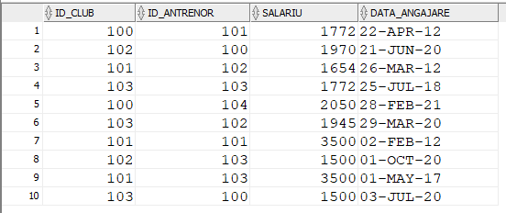

CREATE TABLE LOCATIE (id_locatie int constraint id_locatie_pk PRIMARY KEY,  
 nume VARCHAR(20) CONSTRAINT name_locatie NOT NULL,  
 adresa VARCHAR(20) CONSTRAINT adresa_locatie NOT NULL  
 );  
CREATE SEQUENCE id_locatie  
INCREMENT BY 1  
START WITH 100  
MAXVALUE 100000  
NOCYCLE;  
   
INSERT INTO locatie   
VALUES(id_locatie.NEXTVAL,'Sud Arena','Soseaua Vitan 43')  
INSERT INTO locatie   
VALUES(id_locatie.NEXTVAL,'Fizicienilor','Fizicienilor 2')  
INSERT INTO locatie   
VALUES(id_locatie.NEXTVAL,'Complex Sportiv 12','Trapezului 12')  
INSERT INTO locatie   
VALUES(id_locatie.NEXTVAL,'Arena Nationala','Vatra Luminoasa 5')  
INSERT INTO locatie   
VALUES(id_locatie.NEXTVAL,'Proluceafarul','Monza 45')  
   
SELECT * FROM locatie

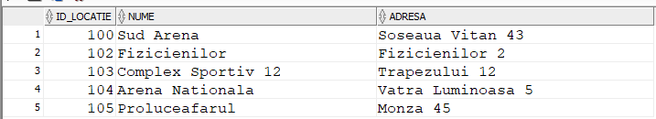CREATE TABLE CLUB_LOCATIE (id_club int, constraint id_club_fk_comp_loc FOREIGN KEY (id_club) references CLUB(id_club),   
 id_locatie int, constraint id_loc_fk_comp FOREIGN KEY (id_locatie) references LOCATIE(id_locatie),  
 data_inchiriere DATE NOT NULL,  
 data_terminare DATE NOT NULL,  
 CONSTRAINT pk_club_locatie primary key(id_club,id_locatie)  
 );  
INSERT INTO Club_Locatie  
VALUES(100,102,TO_DATE('23-05-2021','dd-mm-yyyy'),TO_DATE('23-05-2023','dd-mm-yyyy'))  
INSERT INTO Club_Locatie  
VALUES(101,103,TO_DATE('05-06-2020','dd-mm-yyyy'),TO_DATE('05-06-2022','dd-mm-yyyy'))  
INSERT INTO Club_Locatie  
VALUES(103,102,TO_DATE('21-06-2020','dd-mm-yyyy'),TO_DATE('2-05-2023','dd-mm-yyyy'))  
INSERT INTO Club_Locatie  
VALUES(100,103,TO_DATE('23-05-2021','dd-mm-yyyy'),TO_DATE('23-05-2023','dd-mm-yyyy'))  
INSERT INTO Club_Locatie  
VALUES(104,105,TO_DATE('21-03-2020','dd-mm-yyyy'),TO_DATE('21-03-2024','dd-mm-yyyy'))  
INSERT INTO Club_Locatie  
VALUES(102,104,TO_DATE('16-09-2020','dd-mm-yyyy'),TO_DATE('16-09-2024','dd-mm-yyyy'))  
INSERT INTO Club_Locatie  
VALUES(100,102,TO_DATE('23-05-2021','dd-mm-yyyy'),TO_DATE('23-05-2023','dd-mm-yyyy'))  
INSERT INTO Club_Locatie  
VALUES(103,105,TO_DATE('16-05-2022','dd-mm-yyyy'),TO_DATE('16-05-2023','dd-mm-yyyy'))  
INSERT INTO Club_Locatie  
VALUES(102,103,TO_DATE('22-04-2021','dd-mm-yyyy'),TO_DATE('22-04-2024','dd-mm-yyyy'))  
INSERT INTO Club_Locatie  
VALUES(101,105,TO_DATE('09-09-2022','dd-mm-yyyy'),TO_DATE('09-09-2025','dd-mm-yyyy'))  
INSERT INTO Club_Locatie  
VALUES(102,105,TO_DATE('21-07-2021','dd-mm-yyyy'),TO_DATE('21-07-2025','dd-mm-yyyy'))  
   
SELECT * FROM club_locatie

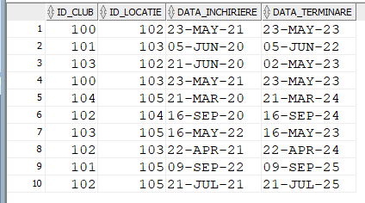

CREATE TABLE SPORTIV_TITLU (id_sportiv int, constraint id_sportiv_fk_titlu FOREIGN KEY (id_sportiv) references SPORTIV(id_sportiv),  
 id_titlu int, constraint id_titlu_fk_titlu FOREIGN KEY (id_titlu) references TITLU(id_titlu),  
 data_obtinere DATE NOT NULL,  
 CONSTRAINT pk_sportiv_titlu_compus primary key(id_sportiv,id_titlu)  
 );  
   
INSERT INTO sportiv_titlu  
VALUES(104,100,TO_DATE('25-05-2021','dd-mm-yyyy'))  
INSERT INTO sportiv_titlu  
VALUES(104,100,TO_DATE('26-05-2021','dd-mm-yyyy'))  
INSERT INTO sportiv_titlu  
VALUES(102,101,TO_DATE('21-02-2014','dd-mm-yyyy'))  
INSERT INTO sportiv_titlu  
VALUES(103,101,TO_DATE('22-06-2015','dd-mm-yyyy'))  
INSERT INTO sportiv_titlu  
VALUES(101,103,TO_DATE('06-01-2013','dd-mm-yyyy'))  
INSERT INTO sportiv_titlu  
VALUES(102,101,TO_DATE('17-02-2021','dd-mm-yyyy'))  
INSERT INTO sportiv_titlu  
VALUES(102,101,TO_DATE('22-03-2022','dd-mm-yyyy'))  
INSERT INTO sportiv_titlu  
VALUES(101,100,TO_DATE('22-03-2021','dd-mm-yyyy'))  
INSERT INTO sportiv_titlu  
VALUES(102,103,TO_DATE('14-02-2023','dd-mm-yyyy'))  
INSERT INTO sportiv_titlu  
VALUES(102,101,TO_DATE('27-05-2021','dd-mm-yyyy'))  
   
SELECT * FROM sportiv_titlu

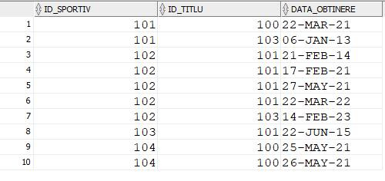

CREATE TABLE ECHIPA_SPONSOR ( id_sponsor int, constraint id_sponsor_fk_echipa FOREIGN KEY (id_sponsor) references SPONSOR(id_sponsor),  
 id_echipa int, constraint id_echipa_fk_sponsor FOREIGN KEY (id_echipa) references ECHIPA(id_echipa),  
 suma_acordata int NOT NULL,  
 data_inceput DATE NOT NULL,  
 data_final DATE NOT NULL,  
 CONSTRAINT pk_echipa_sponsor_compus primary key(id_sponsor,id_echipa)  
 );  
INSERT INTO Echipa_Sponsor  
VALUES(100,102,1540,TO_DATE('23-05-2021','dd-mm-yyyy'),TO_DATE('23-05-2023','dd-mm-yyyy'))  
INSERT INTO Echipa_Sponsor  
VALUES(103,101,1200,TO_DATE('12-06-2029','dd-mm-yyyy'),TO_DATE('12-06-2022','dd-mm-yyyy'))  
INSERT INTO Echipa_Sponsor  
VALUES(102,103,1350,TO_DATE('14-06-2021','dd-mm-yyyy'),TO_DATE('14-06-2025','dd-mm-yyyy'))  
INSERT INTO Echipa_Sponsor  
VALUES(104,101,1300,TO_DATE('08-09-2019','dd-mm-yyyy'),TO_DATE('08-09-2023','dd-mm-yyyy'))  
INSERT INTO Echipa_Sponsor  
VALUES(103,104,1600,TO_DATE('24-06-2020','dd-mm-yyyy'),TO_DATE('24-06-2026','dd-mm-yyyy'))  
INSERT INTO Echipa_Sponsor  
VALUES(102,104,2000,TO_DATE('07-05-2021','dd-mm-yyyy'),TO_DATE('07-05-2023','dd-mm-yyyy'))  
INSERT INTO Echipa_Sponsor  
VALUES(102,101,1300,TO_DATE('14-03-2022','dd-mm-yyyy'),TO_DATE('14-03-2023','dd-mm-yyyy'))  
INSERT INTO Echipa_Sponsor  
VALUES(101,102,1600,TO_DATE('28-09-2019','dd-mm-yyyy'),TO_DATE('28-09-2024','dd-mm-yyyy'))  
INSERT INTO Echipa_Sponsor  
VALUES(103,102,1200,TO_DATE('06-05-2020','dd-mm-yyyy'),TO_DATE('06-05-2023','dd-mm-yyyy'))  
INSERT INTO Echipa_Sponsor  
VALUES(104,100,1540,TO_DATE('25-05-2021','dd-mm-yyyy'),TO_DATE('25-05-2023','dd-mm-yyyy'))  
   
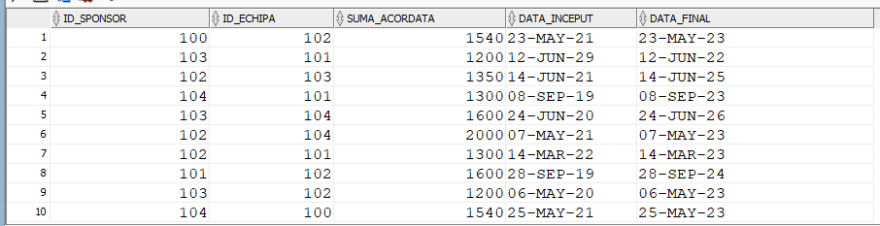SELECT * FROM echipa_sponsor

6. Formulați în limbaj natural o problemă pe care să o rezolvați folosind un subprogram stocat independent care să utilizeze două tipuri diferite de colecții studiate. Apelați subprogramul.

Pentru un Club dat, afisati toti sportivii(nume si DATE de contact) din echipele din cadrul clubului.   
   
CREATE OR REPLACE PROCEDURE cerinta6 (numeclub CLUB.nume%TYPE)  
AS  
 TYPE tablou_indexat IS TABLE OF echipa%ROWTYPE INDEX BY PLS_INTEGER;  
 echipe tablou_indexat;  
 TYPE tablou_imbricat IS TABLE OF sportiv%ROWTYPE;  
 sportivi tablou_imbricat:= tablou_imbricat();  
 cnt NUMBER(4);  
BEGIN  
 SELECT e.id_echipa, e.id_departament, e.nume  
 BULK COLLECT INTO echipe  
 FROM club c, departament d, echipa e  
 WHERE e.id_departament=d.id_departament AND d.id_club = c.id_club AND c.nume=numeclub;  
 FOR i IN 1..echipe.COUNT LOOP  
 DBMS_OUTPUT.put_line('-------------------------------------');  
 DBMS_OUTPUT.put_line('Numele echipei: '||TO_CHAR(echipe(i).nume));  
 cnt:=0;  
 SELECT s.id_sportiv, s.id_echipa, s.nume, s.prenume, s.mail, s.nr_telefon, s.nationalitate, s.data_nasterii  
 BULK COLLECT INTO sportivi  
 FROM sportiv s  
 WHERE s.id_echipa = echipe(i).id_echipa;  
 FOR j IN 1..sportivi.COUNT LOOP  
 cnt:=cnt+1;   
 DBMS_OUTPUT.put_line(TO_CHAR(cnt)||'.');  
 DBMS_OUTPUT.put_line('Nume sportiv: '||sportivi(j).nume);  
 DBMS_OUTPUT.put_line('Prenume sportiv: '||sportivi(j).prenume);  
 DBMS_OUTPUT.put_line('Mail sportiv: '||sportivi(j).mail);  
 DBMS_OUTPUT.put_line('Nr. telefon sportiv: 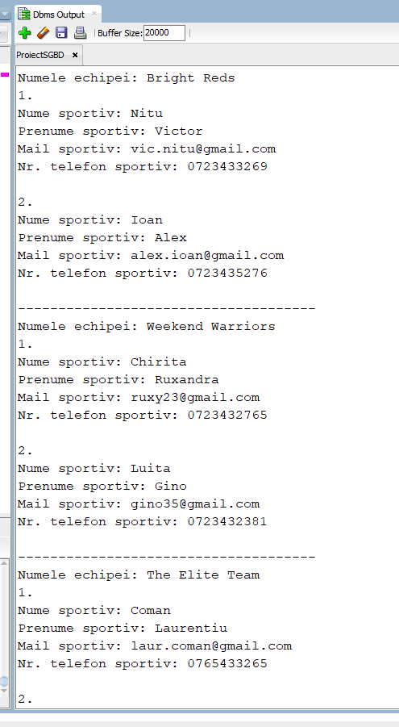'||sportivi(j).nr_telefon);  
 DBMS_OUTPUT.put_line('');  
 END LOOP;  
 END LOOP;   
END;  
/  
   
BEGIN  
cerinta6('CSM Targu Jiu');  
END;  
/

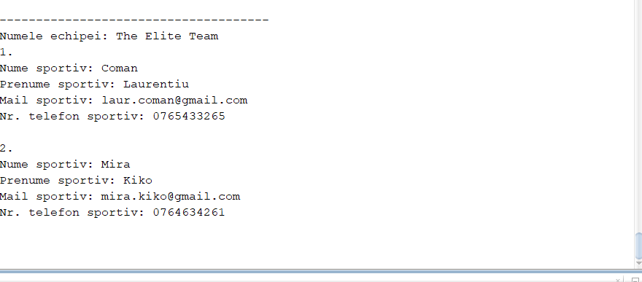

7. Formulați în limbaj natural o problemă pe care să o rezolvați folosind un subprogram stocat independent care să utilizeze 2 tipuri diferite de cursoare studiate, unul dintre acestea fiind cursor parametrizat. Apelați subprogramul.

Pentru un antenor dat(prin nume) afisati pentru competitiile la care a luat parte   
impreuna cu echipa, clubul din care echipa cu un punctaj satisfacator face parte si  
data desfasurarii competitiei. Daca exista mai multi antrenori cu acelasi nume se va alege primul.  
   
   
CREATE OR REPLACE PROCEDURE cerinta7 (nume_antrenor antrenor.nume%TYPE)  
AS  
 id int;  
 CURSOR compet( id antrenor.id_antrenor%TYPE) IS  
 SELECT c.id_echipa, c.data_desfasurarii  
 FROM competitie c, proba p   
 WHERE c.id_antrenor = id AND c.puctaj_obtinut>=p.puctaj_minim AND c.id_proba=p.id_proba ;  
 id_echipe competitie.id_echipa%TYPE;  
 data competitie.data_desfasurarii%TYPE;  
 is_found_rec BOOLEAN := FALSE;   
BEGIN  
 SELECT id_antrenor  
 INTO id  
 FROM antrenor  
 WHERE nume=nume_antrenor AND ROWNUM=1;  
   
 OPEN compet(id);  
 LOOP  
 FETCH compet INTO id_echipe, data;  
 EXIT WHEN compet%NOTFOUND;  
 is_found_rec := TRUE;  
 FOR i IN (SELECT c.nume  
 FROM club c, departament d, echipa e  
 WHERE e.id_departament = d.id_departament AND d.id_club=c.id_club AND e.id_echipa=id_echipe  
 ) LOOP  
 DBMS_OUTPUT.put_line(i.nume);  
 END LOOP;  
 DBMS_OUTPUT.put_line(TO_CHAR(data));  
 DBMS_OUTPUT.put_line('...................');  
 END LOOP;  
 CLOSE compet;  
 IF NOT is_found_rec THEN   
 DBMS_OUTPUT.put_line('Nu exista echipe');  
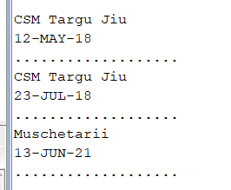 END IF;  
END;  
/

BEGIN

cerinta7('Luiza');

END;

/

# 8. Formulați în limbaj natural o problemă pe care să o rezolvați folosind un subprogram stocat independent de tip funcție care să utilizeze într-o singură comandă SQL3 dintre tabelele definite. Definiți minim 2 excepții. Apelați subprogramul astfel încât să evidențiați toate cazurile tratate.

Pentru un sportiv dat dupa nume calculati numarul de titluri castigate  
CREATE OR REPLACE FUNCTION cerinta8 (parametru sportiv.nume%TYPE) RETURN NUMBER AS  
 titluri NUMBER;  
 TYPE tabel_id IS TABLE OF sportiv.id_sportiv%TYPE INDEX BY PLS_INTEGER;  
 id_uri tabel_id;  
 Nu_exista_sportivi EXCEPTION;  
 Nume_repetat EXCEPTION;  
 nu_exista_titluri EXCEPTION;  
BEGIN  
 SELECT id_sportiv  
 BULK COLLECT INTO id_uri  
 FROM sportiv  
 WHERE nume = parametru;  
 IF id_uri.COUNT = 0 THEN   
 RAISE Nu_exista_sportivi;  
 END IF;  
 IF id_uri.COUNT > 1 THEN   
 RAISE Nume_repetat;  
 END IF;  
 SELECT COUNT (s.id_sportiv)  
 INTO titluri  
 FROM sportiv s  
 join sportiv_titlu st ON (s.id_sportiv = st.id_sportiv)  
 join titlu t  
 ON t.id_titlu = st.id_titlu  
 WHERE s.id_sportiv = id_uri(1);  
 IF titluri = 0 THEN   
 RAISE nu_exista_titluri;  
 ELSE  
 RETURN titluri;  
 END IF;  
EXCEPTION   
 WHEN nu_exista_sportivi THEN   
 DBMS_OUTPUT.put_line('Nu exista aceast sportiv');   
 RETURN -1;  
 WHEN Nume_repetat THEN   
 DBMS_OUTPUT.put_line('exista mai multi sportivi cu acest nume');  
 RETURN -1;  
 WHEN nu_exista_titluri THEN   
 DBMS_OUTPUT.put_line('Acest sportiv nu detine titluri castigate');   
 RETURN -1;  
END;  
/  
   
 DECLARE   
 nr NUMBER;  
 BEGIN   
 nr:=cerinta8('Ioan');  
 IF(nr>=1) THEN  
 DBMS_OUTPUT.put_line('Acest sportiv a obtinut '|| TO_CHAR(nr) || ' titluri');  
 END IF;  
 END;  
   
 DECLARE   
 nr NUMBER;  
 BEGIN   
 nr:=cerinta8('Ion');  
 IF(nr>=1) THEN  
 DBMS_OUTPUT.put_line('Acest sportiv a obtinut '|| TO_CHAR(nr) || ' titluri');  
 END IF;  
 END;  
   
 DECLARE   
 nr NUMBER;  
 BEGIN   
 nr:=cerinta8('Maria');  
 IF(nr>=1) THEN  
 DBMS_OUTPUT.put_line('Acest sportiv a obtinut '|| TO_CHAR(nr) || ' titluri');  
 END IF;  
 END;  
   
 DECLARE   
 nr NUMBER;  
 BEGIN   
 nr:=cerinta8('Luita');  
 IF(nr>=1) THEN  
 DBMS_OUTPUT.put_line('Acest sportiv a obtinut '|| TO_CHAR(nr) || ' titluri');  
 END IF;  
 END;

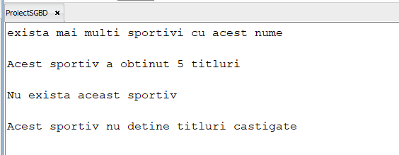

# 9. Formulați în limbaj natural o problemă pe care să o rezolvați folosind un subprogram stocat independent de tip procedură care să utilizeze într-o singură comandăSQL5 dintre tabelele definite. Tratați toate excepțiile care pot apărea, incluzând excepțiile NO_DATA_FOUND și TOO_MANY_ROWS. Apelați subprogramul astfel încât să evidențiați toate cazurile tratate.

Pentru un club afisati numele sportivilor si nr de titluri dobandite  
   
 CREATE OR REPLACE PROCEDURE cerinta9 (nume_club club.nume%TYPE) AS  
 id_club_cautat int;  
 TYPE tabel IS RECORD(  
 id_sportiv_club sportiv.id_sportiv%TYPE,  
 nr_titluri NUMBER  
 );  
 TYPE sportiv_titlu IS TABLE OF tabel;  
 sportiv_titluri sportiv_titlu;  
 nume_sportiv VARCHAR(20);  
 nu_exista EXCEPTION;  
BEGIN  
 SELECT id_club  
 INTO id_club_cautat  
 FROM club  
 WHERE nume = nume_club;  
   
 SELECT s.id_sportiv, COUNT(st.id_titlu)  
 BULK COLLECT INTO sportiv_titluri  
 FROM sportiv s   
 join sportiv_titlu st ON(st.id_sportiv= s.id_sportiv)  
 join echipa e ON(s.id_echipa = e.id_echipa)  
 join departament d ON (e.id_departament = d.id_departament)  
 join club c ON (c.id_club = d.id_club)  
 WHERE c.id_club = id_club_cautat  
 GROUP BY s.id_sportiv;  
 IF sportiv_titluri.COUNT=0 THEN  
 RAISE nu_exista;  
 END IF;  
 FOR i IN 1..sportiv_titluri.COUNT LOOP  
 SELECT nume  
 INTO nume_sportiv  
 FROM sportiv   
 WHERE id_sportiv = sportiv_titluri(i).id_sportiv_club ;  
 DBMS_OUTPUT.put_line('Sportivul '|| nume_sportiv || 'a obtinut ' || sportiv_titluri(i).nr_titluri || ' titluri' );  
 END LOOP;   
EXCEPTION   
   
 WHEN NO_DATA_FOUND THEN   
 DBMS_OUTPUT.put_line('Nu exista aceast club');   
 WHEN TOO_MANY_ROWS THEN   
 DBMS_OUTPUT.put_line('Exista mai multe cluburi cu acelasi nume');   
 WHEN nu_exista THEN   
 DBMS_OUTPUT.put_line('Clubul nu are sportivi');   
END;

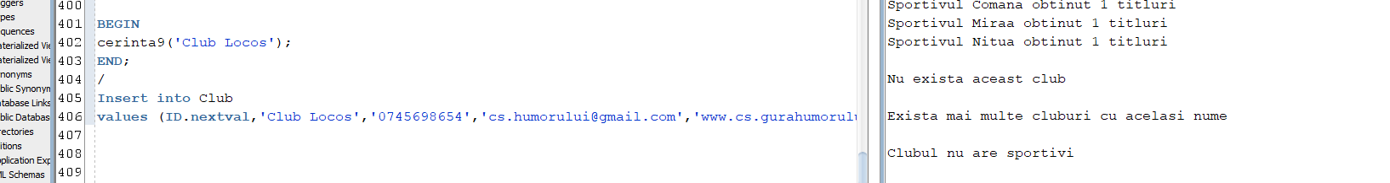

# 10. Definiți un trigger de tip LMD la nivel de comandă. Declanșați trigger-ul.

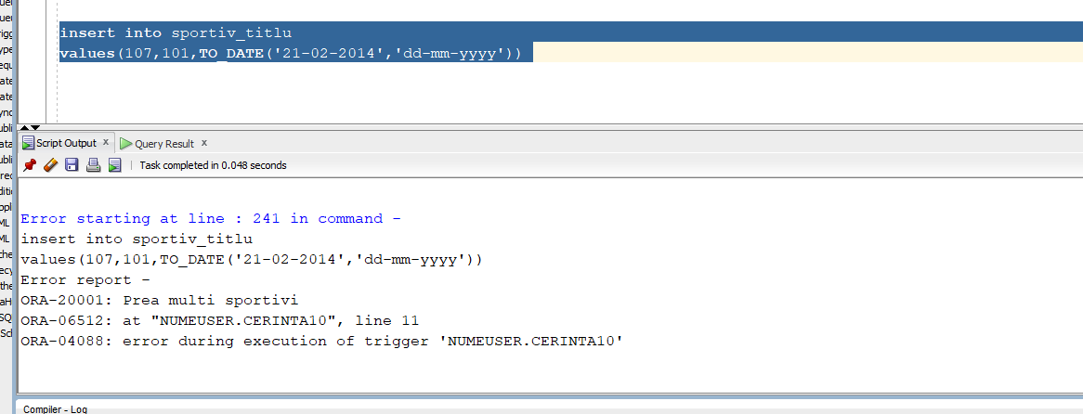IN tabela sportiv_titlu pot fi inserati maxim 6 sportivi diferiti  
   
 CREATE OR REPLACE TRIGGER cerinta10   
before INSERT ON sportiv_titlu  
DECLARE   
 sportivi NUMBER;  
BEGIN   
 SELECT COUNT (DISTINCT (s.id_sportiv))  
 INTO sportivi  
 FROM sportiv s  
 join sportiv_titlu st ON (s.id_sportiv = st.id_sportiv)  
 join titlu t  
 ON t.id_titlu = st.id_titlu;  
 IF sportivi > 5 THEN  
 RAISE_APPLICATION_ERROR(-20001,'Prea multi sportivi');  
 END IF;  
END;

# 11. Definiți un trigger de tip LMD la nivel de linie. Declanșați trigger-ul.

Atunci cand un sportiv isi schimba echipa, suma acordata de sponsori va creste cu 100 pentru acea echipa  
   
CREATE OR REPLACE TRIGGER cerinta11   
 after UPDATE OF id_echipa ON sportiv  
 FOR each ROW  
DECLARE  
 exceptie EXCEPTION;  
 TYPE suma IS TABLE OF echipa_sponsor.suma_acordata%TYPE INDEX BY PLS_INTEGER;  
 sume suma;  
BEGIN  
 IF(:old.id_echipa=:NEW.id_echipa)  
 THEN RAISE exceptie;  
 END IF;  
 SELECT suma_acordata  
 BULK COLLECT INTO sume  
 FROM echipa_sponsor  
 WHERE id_echipa=(:NEW.id_echipa);  
 FOR i IN 1..sume.COUNT LOOP  
 UPDATE echipa_sponsor  
 SET suma_acordata = sume(i)+100  
 WHERE id_echipa = (:NEW.id_echipa);  
 END LOOP;  
   
EXCEPTION   
 WHEN exceptie THEN  
 RAISE_APPLICATION_ERROR (-20003, 'Sportivul nu s-a mutat din echipa');   
 END;   
   
   
 UPDATE sportiv  
 SET id_echipa=101  
 WHERE id_sportiv=100;

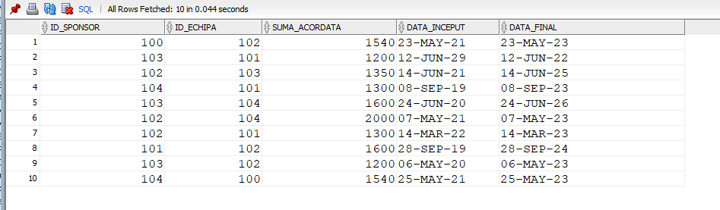Inainte

Dupa

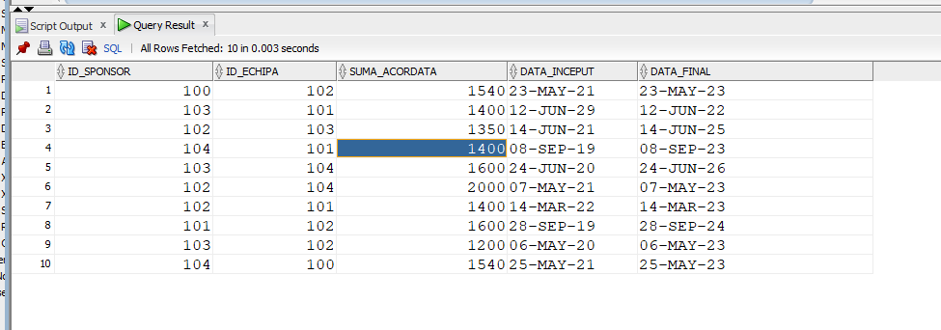

12. Definiți un trigger de tip LDD. Declanșați trigger-ul.  
   
CREATE TABLE istoric  
 (utilizator VARCHAR2(30),  
 nume_bd VARCHAR2(50),  
 eveniment VARCHAR2(20),  
 nume_obiect VARCHAR2(30),  
 data DATE);  
   
CREATE OR REPLACE TRIGGER cerinta12  
AFTER CREATE OR ALTER OR DROP ON SCHEMA  
BEGIN  
 INSERT INTO istoric  
 VALUES (SYS.LOGIN_USER, SYS.DATABASE_NAME, SYS.SYSEVENT,SYS.DICTIONARY_OBJ_NAME, SYSDATE);  
END;  
   
   
 CREATE TABLE Persons (  
 PersonID int,  
 LastName VARCHAR(255),  
 FirstName VARCHAR(255),  
 Address VARCHAR(255),  
 City VARCHAR(255)  
);   
   
ALTER TABLE Persons DROP column City;  
   
DROP TABLE Persons;  
   
SELECT * FROM istoric;

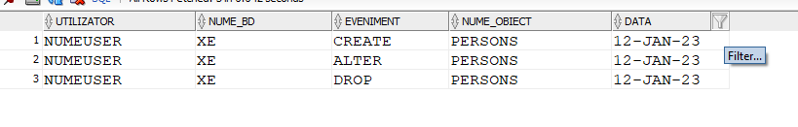

# 13. Definiți un pachet care să conțină toate obiectele definite în cadrul proiectului.

CREATE OR REPLACE PACKAGE cerinta13 AS   
 PROCEDURE cerinta6 (numeclub CLUB.nume%TYPE);  
 PROCEDURE cerinta7 (nume_antrenor antrenor.nume%TYPE);  
 FUNCTION cerinta8 (parametru sportiv.nume%TYPE) RETURN NUMBER;  
 PROCEDURE cerinta9 (nume_club club.nume%TYPE);  
END cerinta13;  
/  
CREATE OR REPLACE PACKAGE BODY cerinta13  
AS  
 PROCEDURE cerinta6 (numeclub CLUB.nume%TYPE)  
AS  
 TYPE tablou_indexat IS TABLE OF echipa%ROWTYPE INDEX BY PLS_INTEGER;  
 echipe tablou_indexat;  
 TYPE tablou_imbricat IS TABLE OF sportiv%ROWTYPE;  
 sportivi tablou_imbricat:= tablou_imbricat();  
 cnt NUMBER(4);  
BEGIN  
 SELECT e.id_echipa, e.id_departament, e.nume  
 BULK COLLECT INTO echipe  
 FROM club c, departament d, echipa e  
 WHERE e.id_departament=d.id_departament AND d.id_club = c.id_club AND c.nume=numeclub;  
 FOR i IN 1..echipe.COUNT LOOP  
 DBMS_OUTPUT.put_line('-------------------------------------');  
 DBMS_OUTPUT.put_line('Numele echipei: '||TO_CHAR(echipe(i).nume));  
 cnt:=0;  
 SELECT s.id_sportiv, s.id_echipa, s.nume, s.prenume, s.mail, s.nr_telefon, s.nationalitate, s.data_nasterii  
 BULK COLLECT INTO sportivi  
 FROM sportiv s  
 WHERE s.id_echipa = echipe(i).id_echipa;  
 FOR j IN 1..sportivi.COUNT LOOP  
 cnt:=cnt+1;   
 DBMS_OUTPUT.put_line(TO_CHAR(cnt)||'.');  
 DBMS_OUTPUT.put_line('Nume sportiv: '||sportivi(j).nume);  
 DBMS_OUTPUT.put_line('Prenume sportiv: '||sportivi(j).prenume);  
 DBMS_OUTPUT.put_line('Mail sportiv: '||sportivi(j).mail);  
 DBMS_OUTPUT.put_line('Nr. telefon sportiv: '||sportivi(j).nr_telefon);  
 DBMS_OUTPUT.put_line('');  
 END LOOP;  
 END LOOP;   
END cerinta6;  
 PROCEDURE cerinta7 (nume_antrenor antrenor.nume%TYPE)  
AS  
 id int;  
 CURSOR compet( id antrenor.id_antrenor%TYPE) IS  
 SELECT c.id_echipa, c.data_desfasurarii  
 FROM competitie c, proba p   
 WHERE c.id_antrenor = id AND c.puctaj_obtinut>=p.puctaj_minim AND c.id_proba=p.id_proba ;  
 id_echipe competitie.id_echipa%TYPE;  
 data competitie.data_desfasurarii%TYPE;  
 is_found_rec BOOLEAN := FALSE;   
BEGIN  
 SELECT id_antrenor  
 INTO id  
 FROM antrenor  
 WHERE nume=nume_antrenor AND ROWNUM=1;  
   
 OPEN compet(id);  
 LOOP  
 FETCH compet INTO id_echipe, data;  
 EXIT WHEN compet%NOTFOUND;  
 is_found_rec := TRUE;  
 FOR i IN (SELECT c.nume  
 FROM club c, departament d, echipa e  
 WHERE e.id_departament = d.id_departament AND d.id_club=c.id_club AND e.id_echipa=id_echipe  
 ) LOOP  
 DBMS_OUTPUT.put_line(i.nume);  
 END LOOP;  
 DBMS_OUTPUT.put_line(TO_CHAR(data));  
 DBMS_OUTPUT.put_line('...................');  
 END LOOP;  
 CLOSE compet;  
 IF NOT is_found_rec THEN   
 DBMS_OUTPUT.put_line('Nu exista echipe');  
 END IF;  
END cerinta7;  
 FUNCTION cerinta8 (parametru sportiv.nume%TYPE) RETURN NUMBER AS  
 titluri NUMBER;  
 TYPE tabel_id IS TABLE OF sportiv.id_sportiv%TYPE INDEX BY PLS_INTEGER;  
 id_uri tabel_id;  
 Nu_exista_sportivi EXCEPTION;  
 Nume_repetat EXCEPTION;  
 nu_exista_titluri EXCEPTION;  
BEGIN  
 SELECT id_sportiv  
 BULK COLLECT INTO id_uri  
 FROM sportiv  
 WHERE nume = parametru;  
 IF id_uri.COUNT = 0 THEN   
 RAISE Nu_exista_sportivi;  
 END IF;  
 IF id_uri.COUNT > 1 THEN   
 RAISE Nume_repetat;  
 END IF;  
 SELECT COUNT (s.id_sportiv)  
 INTO titluri  
 FROM sportiv s  
 join sportiv_titlu st ON (s.id_sportiv = st.id_sportiv)  
 join titlu t  
 ON t.id_titlu = st.id_titlu  
 WHERE s.id_sportiv = id_uri(1);  
 IF titluri = 0 THEN   
 RAISE nu_exista_titluri;  
 ELSE  
 RETURN titluri;  
 END IF;  
EXCEPTION   
 WHEN nu_exista_sportivi THEN   
 DBMS_OUTPUT.put_line('Nu exista aceast sportiv');   
 RETURN -1;  
 WHEN Nume_repetat THEN   
 DBMS_OUTPUT.put_line('exista mai multi sportivi cu acest nume');  
 RETURN -1;  
 WHEN nu_exista_titluri THEN   
 DBMS_OUTPUT.put_line('Acest sportiv nu detine titluri castigate');   
 RETURN -1;  
END cerinta8;  
 PROCEDURE cerinta9 (nume_club club.nume%TYPE) AS  
 id_club_cautat int;  
 TYPE tabel IS RECORD(  
 id_sportiv_club sportiv.id_sportiv%TYPE,  
 nr_titluri NUMBER  
 );  
 TYPE sportiv_titlu IS TABLE OF tabel;  
 sportiv_titluri sportiv_titlu;  
 nume_sportiv VARCHAR(20);  
 nu_exista EXCEPTION;  
BEGIN  
 SELECT id_club  
 INTO id_club_cautat  
 FROM club  
 WHERE nume = nume_club;  
   
 SELECT s.id_sportiv, COUNT(st.id_titlu)  
 BULK COLLECT INTO sportiv_titluri  
 FROM sportiv s   
 join sportiv_titlu st ON(st.id_sportiv= s.id_sportiv)  
 join echipa e ON(s.id_echipa = e.id_echipa)  
 join departament d ON (e.id_departament = d.id_departament)  
 join club c ON (c.id_club = d.id_club)  
 WHERE c.id_club = id_club_cautat  
 GROUP BY s.id_sportiv;  
 IF sportiv_titluri.COUNT=0 THEN  
 RAISE nu_exista;  
 END IF;  
 FOR i IN 1..sportiv_titluri.COUNT LOOP  
 SELECT nume  
 INTO nume_sportiv  
 FROM sportiv   
 WHERE id_sportiv = sportiv_titluri(i).id_sportiv_club ;  
 DBMS_OUTPUT.put_line('Sportivul '|| nume_sportiv || 'a obtinut ' || sportiv_titluri(i).nr_titluri || ' titluri' );  
 END LOOP;   
EXCEPTION   
   
 WHEN NO_DATA_FOUND THEN   
 DBMS_OUTPUT.put_line('Nu exista aceast club');   
 WHEN TOO_MANY_ROWS THEN   
 DBMS_OUTPUT.put_line('Exista mai multe cluburi cu acelasi nume');   
 WHEN nu_exista THEN   
 DBMS_OUTPUT.put_line('Clubul nu are sportivi');   
END cerinta9;  
END cerinta13;  
/  
   
EXECUTE cerinta13.cerinta6('CSM Targu Jiu');

# 14. Definiți un pachet care să includă tipuri de date complexe și obiecte necesare unui flux de acțiuni integrate, specifice bazei de date definite (minim 2 tipuri de date, minim 2 funcții, minim 2 proceduri).

CREATE TYPE antrenori AS OBJECT (  
 id int,  
 nume_antrenor VARCHAR(20)  
);  
CREATE OR REPLACE TYPE antrenori_tip AS TABLE OF antrenori ;   
   
CREATE OR REPLACE PACKAGE cerinta14 AS  
   
 FUNCTION AntrenoriPremii RETURN antrenori_tip;  
 PROCEDURE GetInformatiiClub (numeclub CLUB.nume%TYPE);  
 PROCEDURE UpdateSalariu ;  
 FUNCTION Suma_Sponsori (numeclub CLUB.nume%TYPE) RETURN NUMBER;  
 END cerinta14;  
 /

CREATE OR REPLACE PACKAGE BODY cerinta14 AS  
 FUNCTION AntrenoriPremii RETURN antrenori_tip AS  
 antrenori_returnare antrenori_tip := antrenori_tip();  
 TYPE tabel IS RECORD(  
 id_antrenor_club antrenor.id_antrenor%TYPE,  
 nr_competitii NUMBER  
 );  
 TYPE antrenor_cometitie IS TABLE OF tabel;  
 antrenor_competitii antrenor_cometitie;  
 no_data_found1 EXCEPTION;  
 nume_antrenor VARCHAR(20);  
 BEGIN   
 SELECT id_antrenor, COUNT(id_antrenor)  
 BULK COLLECT INTO antrenor_competitii  
 FROM competitie  
 GROUP BY id_antrenor;  
   
 IF antrenor_competitii.COUNT = 0  
 THEN RAISE no_data_found1;  
 END IF;  
 FOR i IN 1..antrenor_competitii.COUNT LOOP  
 IF antrenor_competitii(i).nr_competitii>0 THEN  
 SELECT nume  
 INTO nume_antrenor  
 FROM antrenor  
 WHERE id_antrenor = antrenor_competitii(i).id_antrenor_club;  
 antrenori_returnare.extend;  
 antrenori_returnare(antrenori_returnare.COUNT) := antrenori(antrenor_competitii(i).id_antrenor_club,nume_antrenor);  
 END IF;  
 END LOOP;  
 RETURN antrenori_returnare;  
 EXCEPTION   
 WHEN no_data_found1 THEN   
 DBMS_OUTPUT.put_line('Nu exista antrenori');  
 END AntrenoriPremii;  
 PROCEDURE GetInformatiiClub (numeclub CLUB.nume%TYPE) AS  
 id int;  
 nr_locatii NUMBER;  
 nr_antrenori NUMBER;  
 nr_echipe NUMBER;  
 TYPE tablou_indexat IS TABLE OF echipa%ROWTYPE INDEX BY PLS_INTEGER;  
 echipe tablou_indexat;  
 BEGIN  
 SELECT id_club  
 INTO id  
 FROM club  
 WHERE nume = numeclub;  
   
 SELECT COUNT ( c.id_club)  
 INTO nr_locatii  
 FROM club c  
 join club_locatie cl ON (c.id_club = cl.id_club)  
 WHERE c.id_club=id;  
 SELECT COUNT ( c.id_club)  
 INTO nr_antrenori  
 FROM club c  
 join antrenor_club cl ON (c.id_club = cl.id_club)  
 WHERE c.id_club=id;  
   
 SELECT e.id_echipa, e.id_departament, e.nume  
 BULK COLLECT INTO echipe  
 FROM club c, departament d, echipa e  
 WHERE e.id_departament=d.id_departament AND d.id_club = c.id_club AND c.nume=numeclub;  
   
 nr_echipe := echipe.COUNT;  
   
 DBMS_OUTPUT.put_line( 'Nr de locatii '|| TO_CHAR(nr_locatii));  
 DBMS_OUTPUT.put_line( 'Nr de antrenori '|| TO_CHAR(nr_antrenori));  
 DBMS_OUTPUT.put_line( 'Nr de echipe '|| TO_CHAR(nr_echipe));   
 EXCEPTION  
 WHEN NO_DATA_FOUND THEN   
 DBMS_OUTPUT.put_line('Nu exista aceast club');   
 WHEN TOO_MANY_ROWS THEN   
 DBMS_OUTPUT.put_line('Exista mai multe cluburi cu acelasi nume');   
END GetInformatiiClub;  
 PROCEDURE UpdateSalariu AS  
 TYPE tablou_indexat IS TABLE OF NUMBER INDEX BY PLS_INTEGER;  
 suma tablou_indexat;  
 BEGIN  
 FOR i IN ( SELECT id FROM TABLE(cerinta14.AntrenoriPremii)) LOOP  
 SELECT salariu   
 BULK COLLECT INTO suma  
 FROM antrenor_club  
 WHERE id_antrenor=i.id;  
 FOR j IN 1..suma.COUNT LOOP  
 FOR k IN (SELECT * FROM antrenor_club) LOOP  
 UPDATE antrenor_club  
 SET salariu = suma(j)+100  
 WHERE id_antrenor = i.id;  
 END LOOP;  
 END LOOP;  
 END LOOP;   
EXCEPTION  
 WHEN NO_DATA_FOUND THEN   
 DBMS_OUTPUT.put_line('Nu exista antrenori');   
END UpdateSalariu;  
 FUNCTION Suma_Sponsori(numeclub CLUB.nume%TYPE) RETURN NUMBER AS  
 TYPE tablou_indexat IS TABLE OF echipa%ROWTYPE INDEX BY PLS_INTEGER;  
 TYPE tablou_indexat_numere IS TABLE OF NUMBER INDEX BY PLS_INTEGER;  
 echipe tablou_indexat;  
 suma_totala NUMBER;  
 suma_curenta tablou_indexat_numere;  
 exceptie EXCEPTION;  
 aux NUMBER;  
 BEGIN  
   
 SELECT e.id_echipa, e.id_departament, e.nume  
 BULK COLLECT INTO echipe  
 FROM club c, departament d, echipa e  
 WHERE e.id_departament=d.id_departament AND d.id_club = c.id_club AND c.nume=numeclub;  
   
 IF echipe.COUNT=0 THEN  
 RAISE NO_DATA_FOUND;  
 END IF;  
 suma_totala:=0;  
 FOR i IN 1..echipe.COUNT LOOP  
 SELECT suma_acordata  
 BULK COLLECT INTO suma_curenta  
 FROM echipa_sponsor  
 WHERE id_echipa=echipe(i).id_echipa;  
 FOR j IN 1..suma_curenta.COUNT LOOP  
 aux:=suma_totala;  
 suma_totala := suma_curenta(j)+aux;  
 END LOOP;  
 END LOOP;  
   
 IF suma_totala=0 THEN  
 RAISE exceptie;  
 END IF;  
 RETURN suma_totala;   
EXCEPTION  
 WHEN NO_DATA_FOUND THEN   
 DBMS_OUTPUT.put_line('Nu exista antrenori');   
 WHEN exceptie THEN   
 DBMS_OUTPUT.put_line('Clubul nu beneficiaza de sponsori');   
END Suma_Sponsori;  
END cerinta14;  
/

EXECUTE cerinta14.getinformatiiclub('CSM Targu Jiu')   
EXECUTE cerinta14.updatesalariu;   
   
DECLARE   
   
 a NUMBER;   
   
BEGIN   
   
 a:=cerinta14.suma_sponsori('CSM Targu Jiu');   
   
 DBMS_OUTPUT.put_line('Suma totala a clubului ' || a);   
   
END;

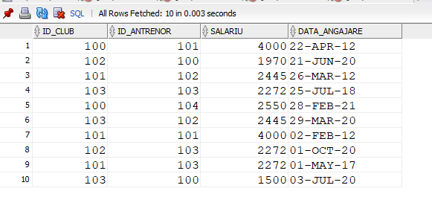Inainte

Dupa

